#include<iostream>

#include<string.h>

#include<string>

#include<stdio.h>

#include<math.h>

#include<conio.h>

#include<windows.h>

#include <stdlib.h>

#include <fstream>

#include<ctime>

#include <dos.h>

void time();

void time()

{

time_t tt;

struct tm * ti;

time (&tt);

ti = localtime(&tt);

std::cout<<"\t\t\t\t\t" <<asctime(ti);

}

using namespace std;

string userdata_1();//function for input and output operations also calculates the units consumed

struct userdata

{

char name[100];//stores name

float units;//stores units consumed

long int customerid;//stores customer id

char billtype;//stores bill type

};

class userdatacal{

public:

void exitdisplay()

{

system("cls");

string bye = "Thank you:)";

int x=0;

while ( bye[x] != '\0')

{

cout << bye[x];

Sleep(100);

x++;

};

getch();

exit(0);

}

string userdata1()

{ int i=1,n;

userdata user;

char email1,email2,email3;

email1=80;

email2=70;

email3=65;

email1++;

email2++;

email3++;

system("cls");

cout<<"\nEnter the number of entries you want ";

cin>>n;

int exitcaller;

int l;

l=0;

exitcaller=1;

for(i=0;i<=n;i++)

{

cout<<"Please fill in the details"<<endl;

cout<<"Name: ";

cin>>user.name;

cout<<"Customer ID: ";

cin>>user.customerid;

cout<<"Bill type:";

cout<<"\nC-Commercial";

cout<<"\nD-Domestic"<<endl;

cin>>user.billtype;

cout<<"Units consumed: ";

cin>>user.units;

system("pause");

system("cls");

if(user.billtype==67||user.billtype==99)

{

cout<<"\n\tUsername: "<<"DSD CORPORATION"<<endl;

cout<<"\n\tCustomer ID: "<<user.customerid<<endl;

cout<<"\n\tUnits consumed: "<<user.units<<"KWH"<<endl;

cout<<"\nADDRESS:";

cout<<"\n\tStreet:"<<20+i<<" DSD Corporation building,3rd Avenue,Bandra(west)";

cout<<"\n\tCity: Mumbai";

cout<<"\n\tState: Maharashtra";

cout<<"\n\tZip Code:"<<400055+2*i;

cout<<"\n\tPhone Number:"<<222205313+2*i;

cout<<"\n\tEmail:"<<email1<<email2<<email3<<"@gmail.com";

float cost,i=0,j=0,k=0,l=0;

//logic for operation works here

if(user.units<101)

{

cost=30+2.96*user.units;

i=cost;

}

else if(user.units<300)

{

cost=50+296+5.56*(user.units-100);

j=cost-296;

i=296+30;

}

else if(user.units<501)

{

cost=50+296+5.56*200+9.16*(user.units-300);

k=cost-(296+5.56*200);

i=296+30;

j=200*5.56+50;

}

else

{

cost=100+296+5.56*200+9.16*200+10.61*(user.units-500);

l=cost-(296+5.56*200+9.16*200);

i=296+30;

j=200*5.56+50;

k=200*9.16+50;

}

cout<<"\n\n";

cout<<" Tariff Stats Fixed charge Energy Charge INR/unit Cost"<<endl;

cout<<" 0-100 30 2.96 "<<i<<endl;

cout<<" 101-300 50 5.56 "<<j<<endl;

cout<<" 301-500 50 9.16 "<<k<<endl;

cout<<" above 500 100 10.61 "<<l<<endl;

cout<<"\n\tAmount payable : INR "<<cost<<endl;

}

else

{

cout<<"\n\tUsername: "<<user.name<<endl;

cout<<"\n\tCustomer ID: "<<user.customerid<<endl;

cout<<"\n\tUnits consumed: "<<user.units<<"KWH"<<endl;

cout<<"\nADDRESS:";

cout<<"\n\tStreet:"<<20+i<<" , Maheshwar Niwas, Tilak Rd, Santacruz (west)";

cout<<"\n\tCity: Mumbai";

cout<<"\n\tState: Maharashtra";

cout<<"\n\tZip Code:"<<400055+2*i;

cout<<"\n\tPhone Number:"<<222205313+2*i;

cout<<"\n\tEmail:"<<email1<<email2<<email3<<"@gmail.com";float cost,i=0,j=0,k=0,l=0;

//logic for operation works here

if(user.units<101)

{

cost=30+2.96*user.units;

i=cost;

}

else if(user.units<300)

{

cost=50+296+5.56*(user.units-100);

j=cost-296;

i=296+30;

}

else if(user.units<501)

{

cost=50+296+5.56*200+9.16*(user.units-300);

k=cost-(296+5.56*200);

i=296+30;

j=200*5.56+50;

}

else

{

cost=100+296+5.56*200+9.16*200+10.61*(user.units-500);

l=cost-(296+5.56*200+9.16*200);

i=296+30;

j=200*5.56+50;

k=200*9.16+50;

}

cout<<"\n\n";

cout<<" Tariff Stats Fixed charge Energy Charge INR/unit Cost"<<endl;

cout<<" 0-100 40 1.96 "<<i<<endl;

cout<<" 101-300 60 4.56 "<<j<<endl;

cout<<" 301-500 70 4.16 "<<k<<endl;

cout<<" above 500 100 12.61 "<<l<<endl;

cout<<"\n\tAmount payable : INR "<<cost<<endl;

}

getch();

system("cls");

l++;

if(l==n)

{

exitdisplay();

}

}}

};

void mainmenu();

void display();

void screendisplay()

{

string hello = "\t\t\t\t\tWelcome to DSD corporation \n\t\t\t\t\tWe are happy to assist you:)\n";

int x=0;

while ( hello[x] != '\0')

{

cout << hello[x];

Sleep(50);

x++;

};

cout<<"Press any key to continue...."<<endl;

getch();

system("cls");

}

int main()

{ time();

screendisplay();

mainmenu();

userdatacal object2_0;

object2_0.exitdisplay();

}

int choice;

bool cinfail;

int confirmation;

string username, password, password2;

void writetofile(string username){

ofstream writefile;

string file = username+".txt";

writefile.open(file.c_str());

writefile << password;

writefile.close();

mainmenu(); }

void loading();

void login(){

system("cls");

userdatacal object3;

string pass ="";

string username;

cout<<"\n\n\n\n\t\t\t\tUsername: ";

cin>>username;

char ch;

cout << "\t\t\t\tPassword: ";

ch = _getch();

while(ch != 13){//character 13 is enter

pass.push_back(ch);

cout << '*';

ch = _getch();

}

loading();

system("cls");

system("cls");

if(pass == "deepisgreat")

{

int userunits;

system("cls");

cout<<"\n\tUsername: Deep Rahul Shah "<<endl;

cout<<"\n\tCustomer ID:9119 "<<endl;

cout<<"\n\tUnits consumed: 2000 "<<"KWH"<<endl;

userunits=2000;

cout<<"\nADDRESS:";

cout<<"\n\tStreet:"<<"20 , Maheshwar Niwas, Tilak Rd, Santacruz (west)";

cout<<"\n\tCity: Mumbai";

cout<<"\n\tState: Maharashtra";

cout<<"\n\tZip Code:"<<400091;

cout<<"\n\tPhone Number:"<<9189021028;

cout<<"\n\tEmail: deep_admin@gmail.com\n\n";

float cost,i=0,j=0,k=0,l=0;

//logic for operation works here

if(userunits<101)

{

cost=30+2.96*userunits;

i=cost;

}

else if(userunits<300)

{

cost=50+296+5.56*(userunits-100);

j=cost-296;

i=296+30;

}

else if(userunits<501)

{

cost=50+296+5.56*200+9.16*(userunits-300);

k=cost-(296+5.56*200);

i=296+30;

j=200*5.56+50;

}

else

{

cost=100+296+5.56*200+9.16*200+10.61*(userunits-500);

l=cost-(296+5.56*200+9.16*200);

i=296+30;

j=200*5.56+50;

k=200*9.16+50;

}

cout<<" Tariff Stats Fixed charge Energy Charge INR/unit Cost"<<endl;

cout<<" 0-100 30 2.96 "<<i<<endl;

cout<<" 101-300 50 5.56 "<<j<<endl;

cout<<" 301-500 50 9.16 "<<k<<endl;

cout<<" above 500 100 10.61 "<<l<<endl;

cout<<"\n\tAmount payable : INR "<<cost<<endl;

cout<<"\n\n\nPress any key to go back to the main menu";

getch();

system("cls");

mainmenu();

}

else

{cout<<"Wrong password,try again:(";

login();

}}

void registerpassword()

{

userdatacal object4;

cout << "Please enter the password:";

cin >> password;

cout << "Please re-enter your password:";

cin >> password2;

if (password == password2){

cin.clear();

cout<<"You have been successfully registered";

cout<<"\n\nYou have been logged in";

cin.ignore(10000,'\n');

object4.userdata1();

}

else;{

cout << "Sorry invalid" << endl;

registerpassword();

}}

void registerme(){

userdatacal object2;

char confirmation;

cout << "Please enter your username: ";

getline(cin, username);

cout << "\nUsername - \""<< username << "\"\nConfirm? \n\nY-Yes\nN-No" << endl;

cin >> confirmation;

if (confirmation == 89||confirmation==121)

{

registerpassword();

}

else; {

cout << "Sorry invalid input, Please try again" << endl;

cin.clear();

cin.ignore(10000,'\n');

registerme();

system("cls");

object2.userdata1();

}}

void exit(){

system("cls");

cout<<"\nAre you sure you want exit";

cout<<"\nY-Yes N-No\n";

char val;

cin>>val;

system("cls");

if(val==78||val==110)

{

mainmenu();

}

else{

system("cls");

string bye = "Thank you:)";

int x=0;

while ( bye[x] != '\0')

{

cout << bye[x];

Sleep(100);

x++;

};

getch();

system("cls");

exit(0);

}

exit(0);}

void mainmenu(){

userdatacal object3;

cout << "Hello, Would you like to log in or register\n[1] Login\n[2] Register\n[3] Exit" <<endl; cin >> choice; do{

cinfail = cin.fail();

cin.clear();

cin.ignore(10000,'\n');

}while(cinfail == true);{

switch(choice){

case 1:

login();

break;

case 2:

registerme();

object3.userdata1();

break;

case 3:

exit();}}}

void loading()

{

system("color 07");

cout<<"\n\n\n\t\t\t\tPlease wait while we are loading\n\n";

char a=177, b=219;

cout<<"\t\t\t\t";

for (int i=0;i<=15;i++)

cout<<a;

cout<<"\r";

cout<<"\t\t\t\t";

for (int i=0;i<=15;i++)

{

cout<<b;

for (int j=0;j<=1e8;j++);

}

system("cls");

}

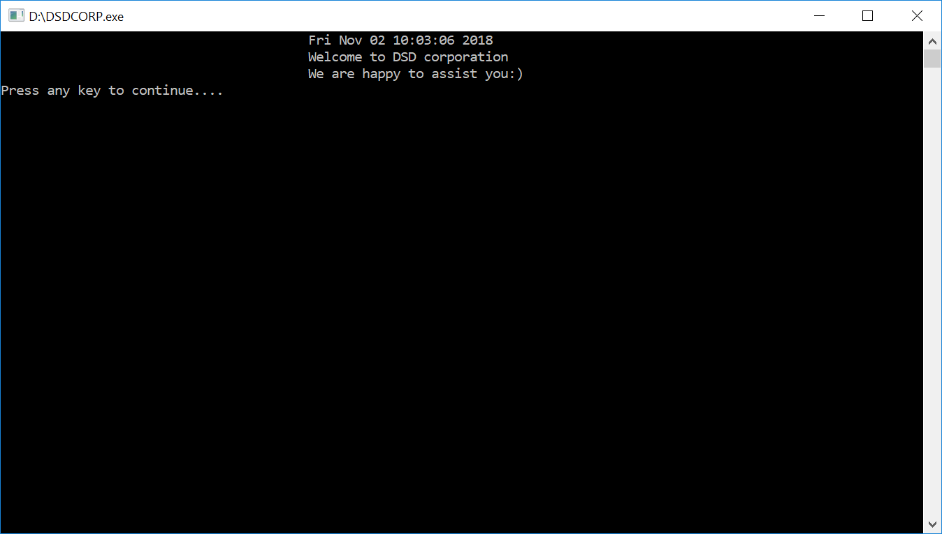

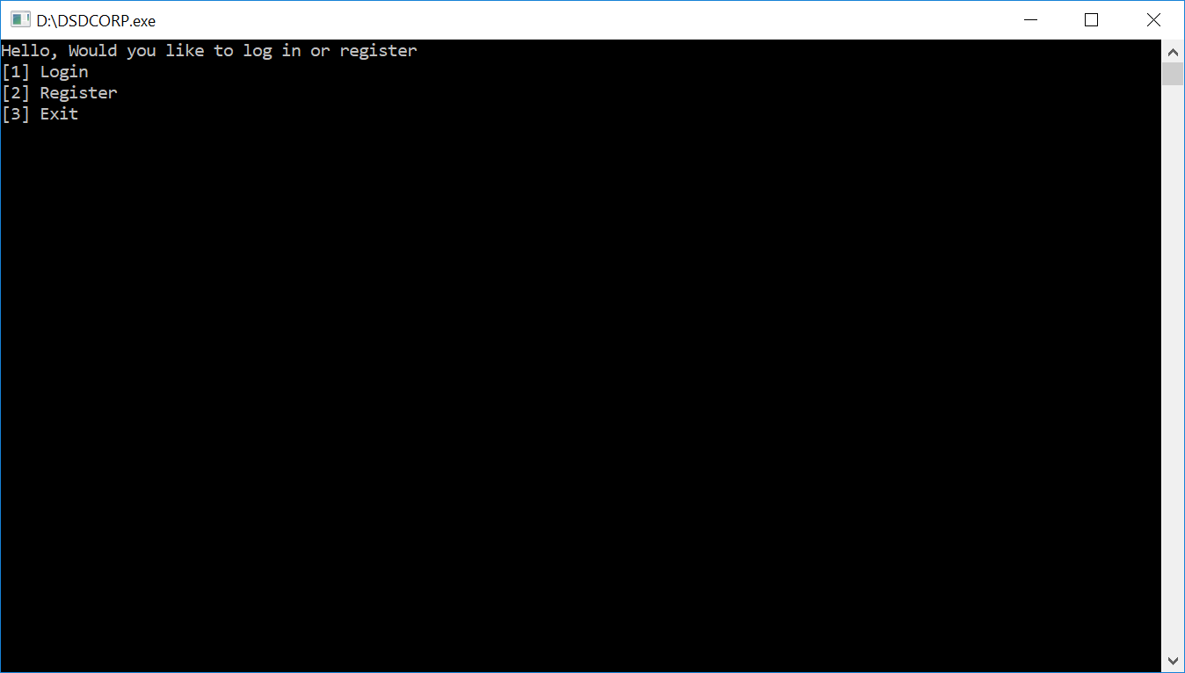

**1)Login**

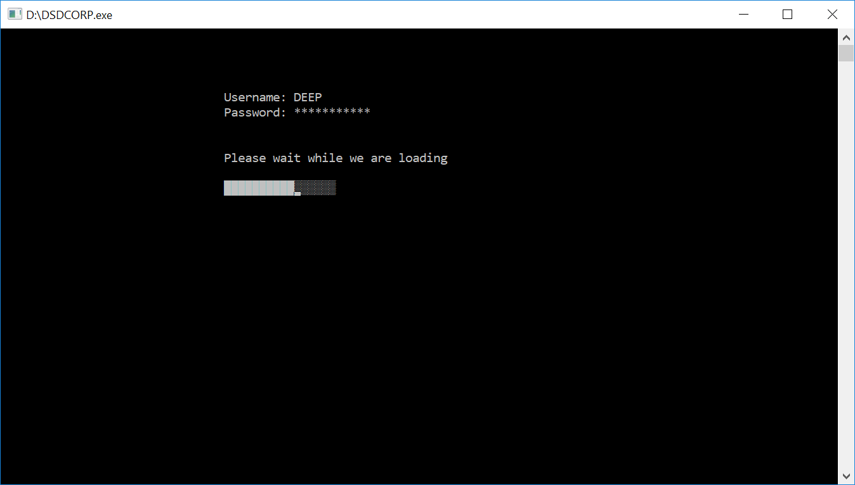

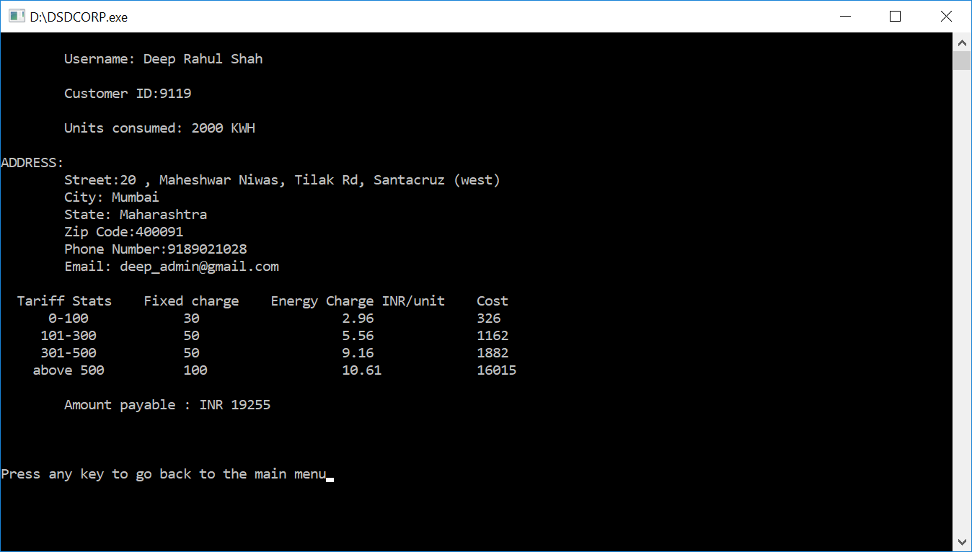

**2)REGISTER**

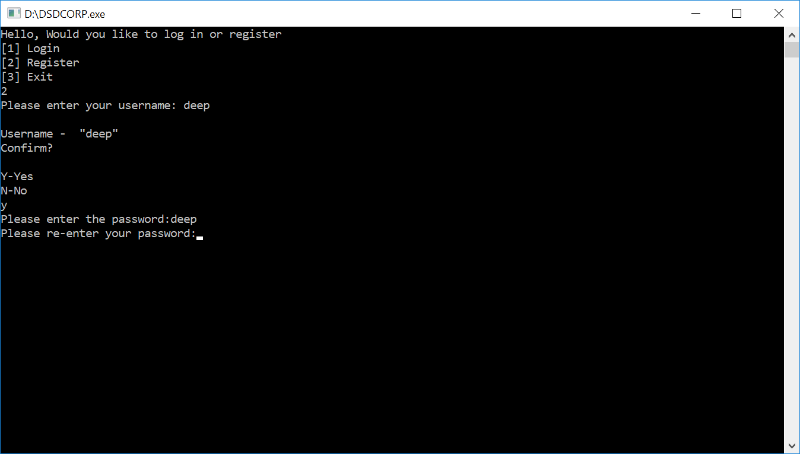

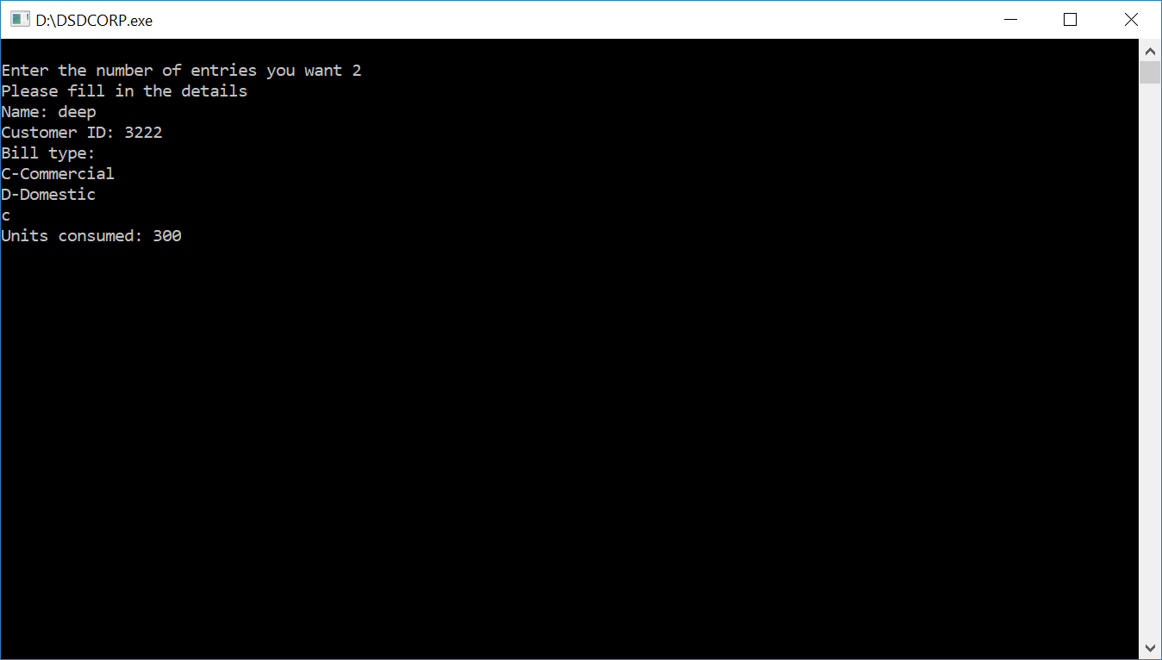

**Commercial**

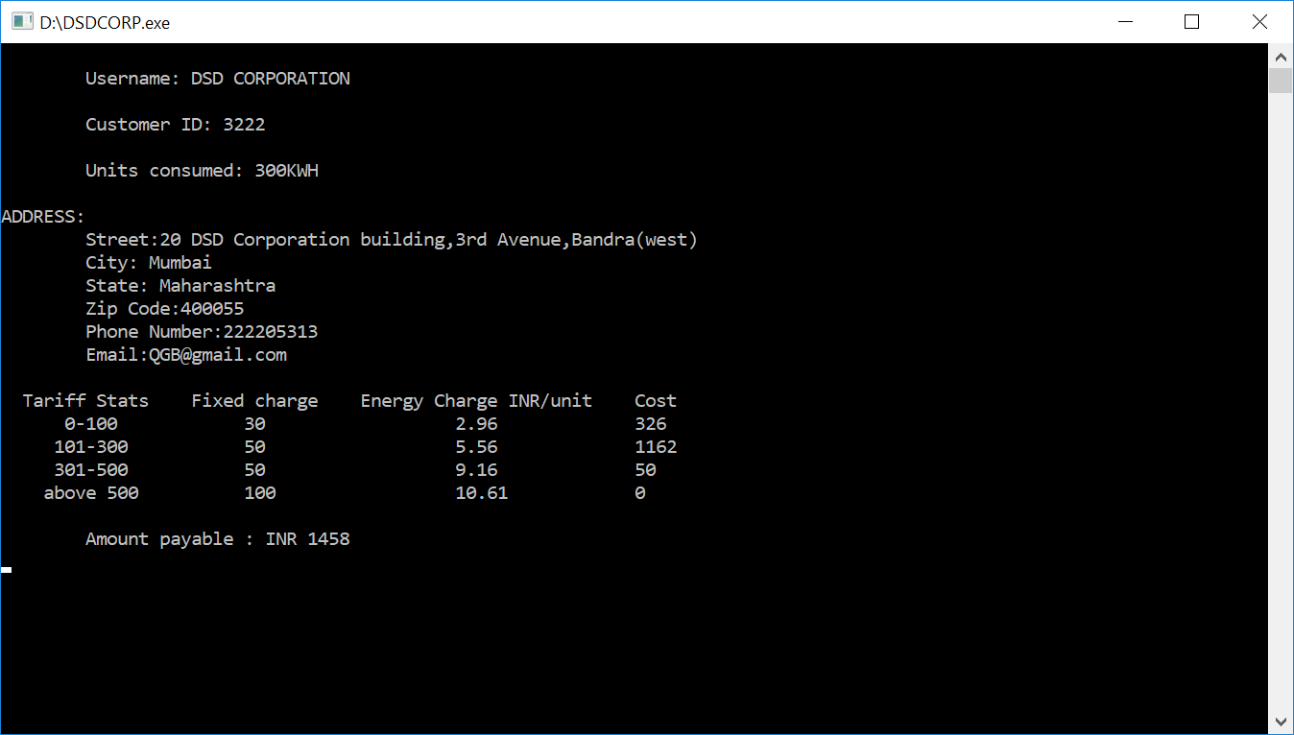

**Domestic**

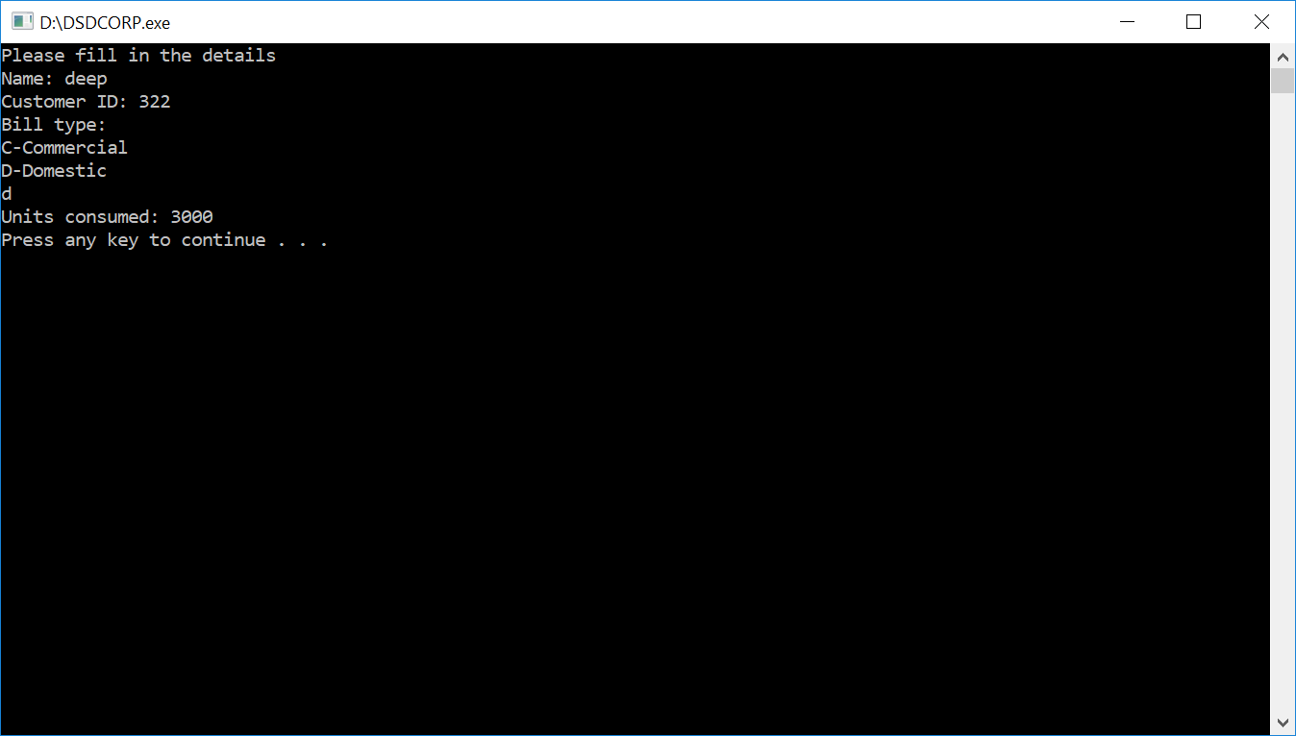

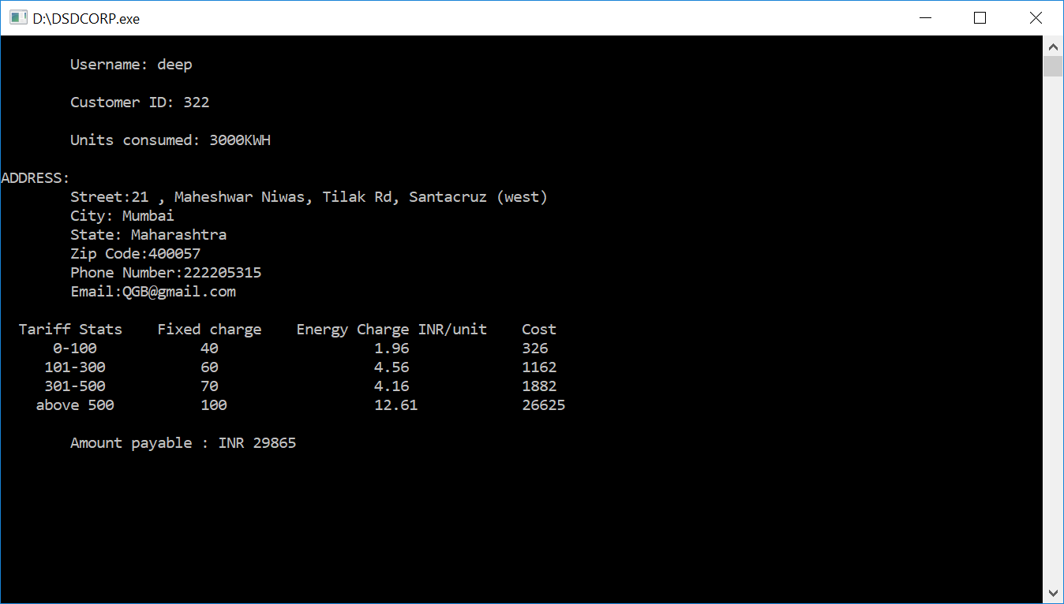

**3)Exit**

